EXPERIMENT – 4

MCQs

1) Gaussian noise is referred to as

A. red noise

B. black noise

C. white noise

D. normal noise

2) PDF in image processing is called

A. probability degraded function

B. probability density function

C. probabilistic degraded function

D. probabilistic density function

3) In wiener filtering it is assumed that noise and image are

A. different

B. homogenous

C. correlated

D. uncorrelated

4) Mean filters reduce noise using

A. sharpening

B. blurring

C. restoration

D. acquisition

5) Degraded image is produced using degradation process and

1. A. additive noise
2. B. destruction
3. C. pixels
4. D. coordinates

6) Approach that incorporates both degradation function and statistical noise in restoration is called

1. A. inverse filtering
2. B. spike filtering
3. C. wiener filtering
4. D. ranking

7) Principle sources of noise arise during image

1. A. destruction
2. B. degradation
3. C. restoration
4. D. acquisition

Answers: 1) C. White noise 2) B. Probability Density Function. 3) D. Uncorrelated 4) B. Blurring 5) A. Additive Noise 6) C. Wiener filtering 7) D. Acquisition

**EXERCISES**

Q1

clc;

clear all;

close all;

A = ones(512,512)*127;

G = imnoise (A,'gaussian');

H = imnoise (A,'poisson');

I = imnoise (A,'salt & pepper');

figure

subplot (221)

imshow(A);

subplot (222)

imshow(G);

subplot (223)

imshow(H);

subplot(224)

imshow (I);

figure

subplot (221)

imhist(A);

subplot (222)

imhist(G);

subplot (223)

imhist(H);

subplot(224)

imhist (I);



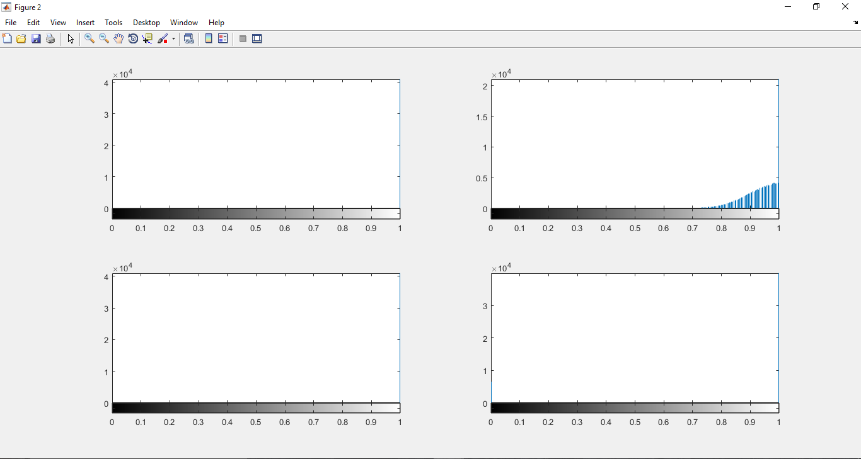

Q2

clc;

clear all;

close all;

RGB = imread('len_top.jpg');

I = rgb2gray(RGB);

J = imnoise(I,'gaussian',0,0.005);

F = fft2(J);

K = wiener2(I,[3 3]);

figure, imshow(K), figure, imshow(J)

X = xcorr2(J);

Y = xcorr2(K);

figure, stem(X),figure,stem(Y)

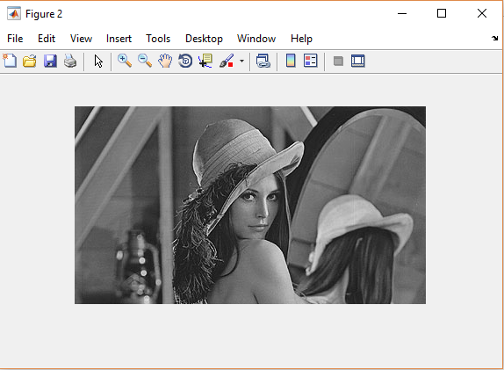

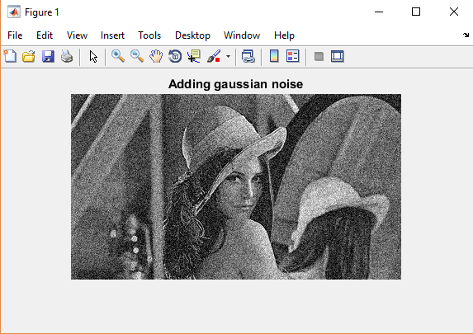

WEINER FILTER OUTPUT

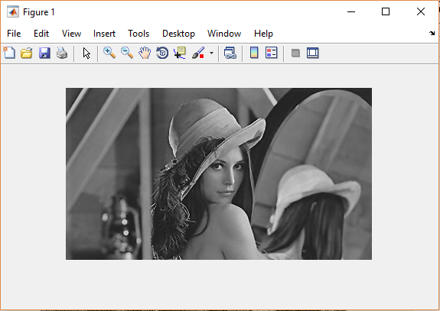

**Autocorrelation of Image with Gaussian Noise**

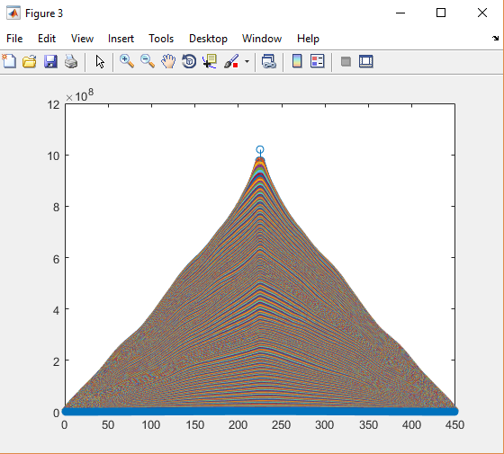

**Autocorrelation of Weiner filtered image**

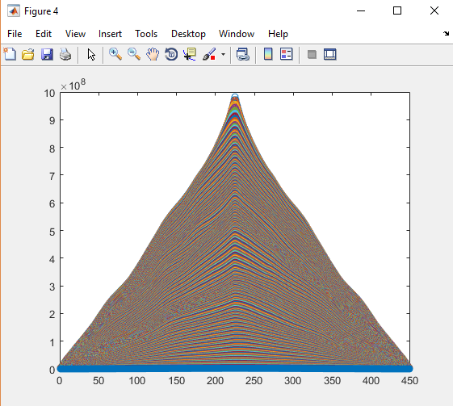

Q3

clc;

clear all;

close all;

RGB = imread('len_top.jpg');

I = rgb2gray(RGB);

J = imnoise(I,'gaussian');

LEN = 31;

THETA = 11;

PSF = fspecial('motion',LEN,THETA); % create PSF

Blurred = imfilter(I,PSF,'circular','conv');

figure; imshow(Blurred); title('Blurred (degradation without noise) Image');

figure; imshow(J); title('Gaussian Noise (degradation with noise)');

err = mean2((I-J).^(2))

